**Slicing**

* **Get element from second position to fifth position from list - [1, 2, 3, 4, 5, 6]**

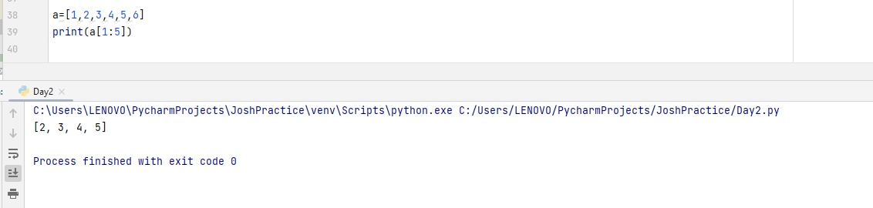

**Condition**

* **Check if string palindrome or not “ab”, “abc”, “aba”**

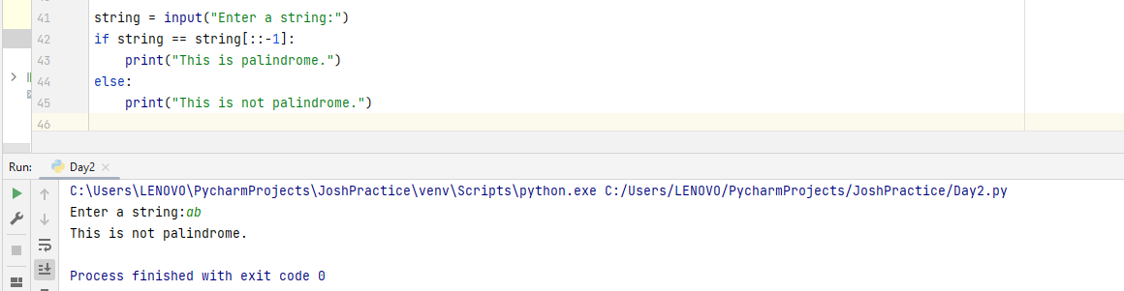

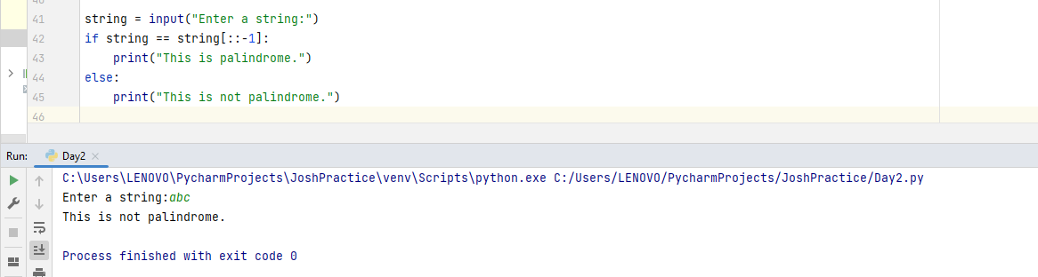

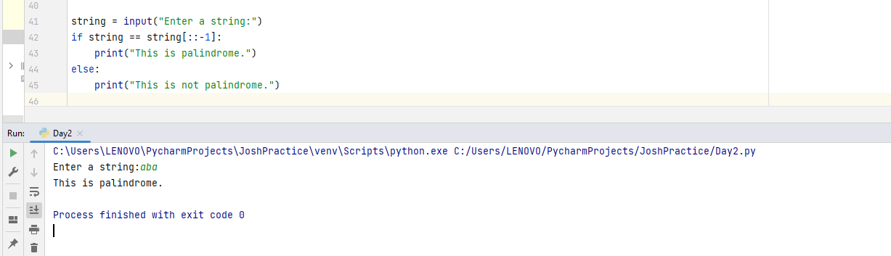

**Loop**

* 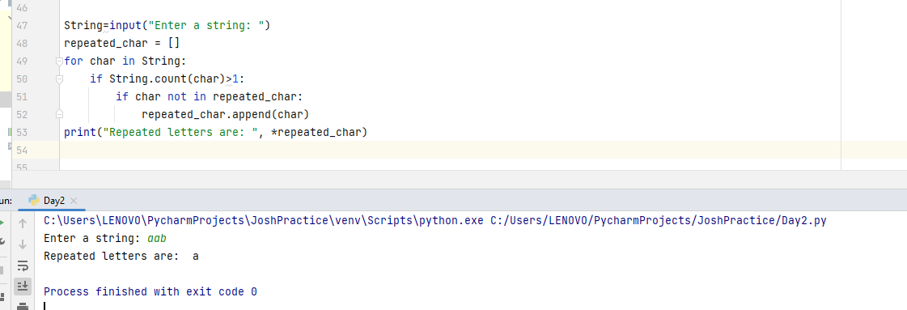**Check if string contains repeated characters “aab”, “abc”, “def”.**

**Function**

* **Convert all the above to function which can work on variadic number of arguments**.

